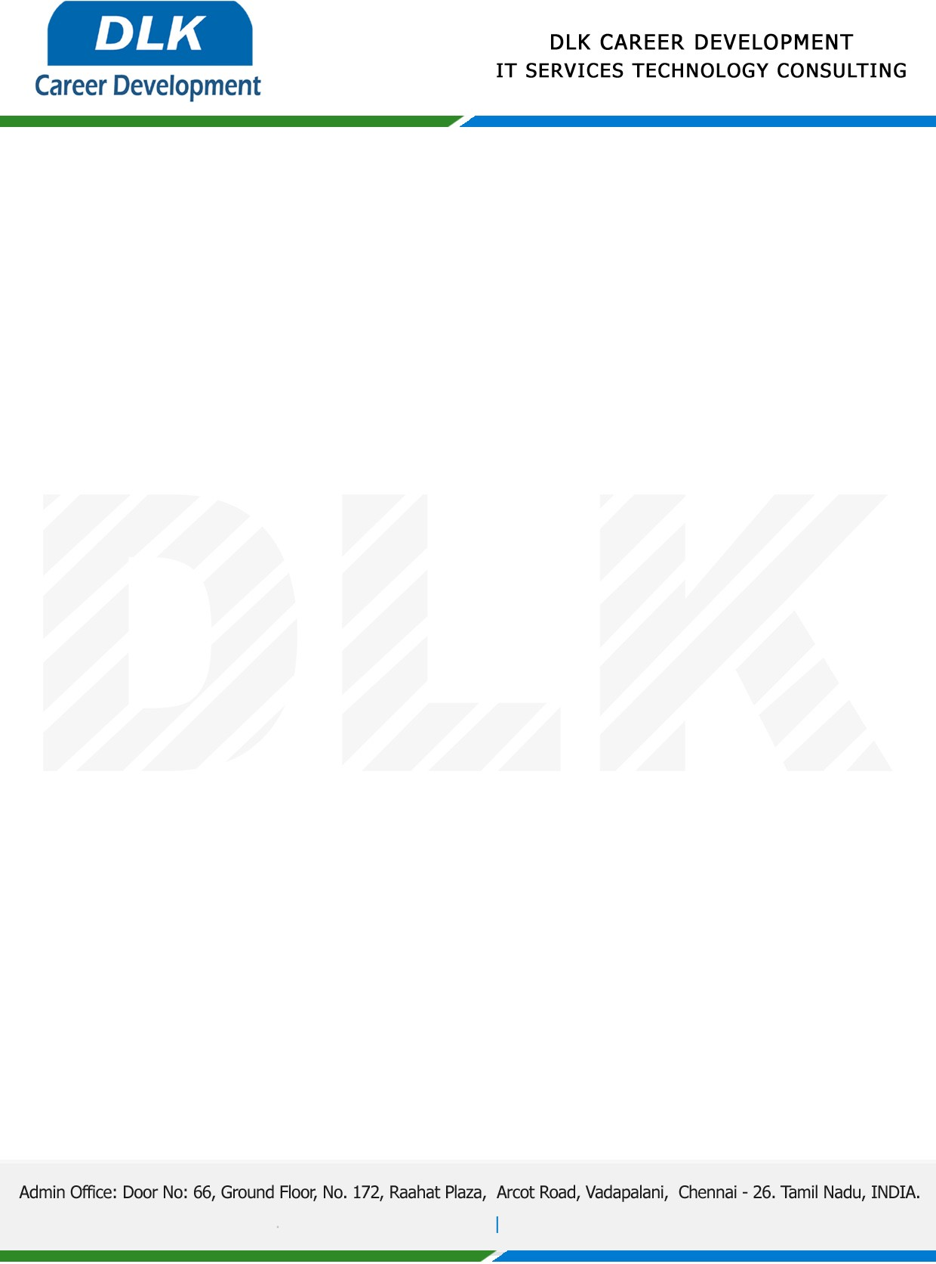

Date: 02/February/2023

**To**

Department of BCA (Computer Application) [,](https://www.cseindia.org/)

Head of Department,

Alpha Arts and Science College, Chennai -  600116.

**Sub: Letter of Project Acceptance**

This is to certify that **MS SWARNALATHA S (REG NO: 212002819)** final year student of has accepted the Project Work duration from **February 2023 to April 2023** under the domain **“Blockchain”.** During the Project, all information and data collected from you should be kept confidential.

**Topic:** Fake Product Identification by QR Code Using Blockchain.

We appreciate your interest in **DLK CAREER DEVELOPMENT**

